2012 – Castlemaine Seed Fishing Report

Note: This report was compiled by the Secretariat to the BGMCF using data provided by the SFPA, BIM and the Marine Institute

# Table of contents

**1.0 Permitted Tonnage**

**2.0 Opening of the Fishery**

**3.0 Vessel Activity**

**4.0 Control Measures**

**4.1 Licensing and Authorisation of vessels**

**4.2 Recording and Notification of effort and catch take**

**4.3 Monitoring, Control and Surveillance**

1. **Habitat monitoring**

**5.1 Introduction**

**5.2 Methods**

**5.2.1 Intertidal mussel cover**

**5.2.2 Seagrass**

**5.3 Results**

**5.3.1 Seagrass**

**5.3.2 Mussel Coverage**

**6.0 Conclusions and recommendations**

**Appendix 1: Seed Mussel Surveys**

# 1.0 Permitted Tonnage

The Minister for Agriculture, Food, and the Marine granted Fisheries Natura Permits under Regulation 5 of the European Communities (Natural Habitats and Birds) (Sea-Fisheries) Regulations 2009 (S.I. No. 346 of 2009), as amended by the European Communities (Habitats and Birds) (Sea-Fisheries) (Amendment) Regulations 2010 (S.I. No. 397 of 2010) and the European Communities (Habitats and Birds) (Sea-Fisheries) (Amendment) Regulations 2012 (S.I. No. 237 of 2012), for the fishing of mussel seed (*Mytilus edulis*) in accordance with Fisheries Natura Declaration No 1 of 2011

In compliance with the Fisheries Natura Declaration No. 1 of 2011, the permitted area was determined by the Minister, based on BIM surveys of mussel spat fall (May and July 2012) and only included areas of outer Castlemaine Harbour that were assessed for sub-tidal mussel seed fishing in the Appropriate Assessment report of April 2011.

The total estimated biomass of mussel seed in the permitted area was documented by BIM on the 26/07/2012 and was 3000 tonnes (See Appendix 1). This generated a TAC of 2000 tonnes.

# 2.0 Opening of the Fishery

The signing of the Fisheries Natura Declaration 2011-2016 (Castlemaine Harbour) allowed for the opening of the Mussel Seed Fishery 2012. This Declaration sets restrictions on the dredging, retaining on board, transplanting and re-laying of Mussel Seed in Castlemaine Harbour.

Mussel Seed Authorisations were granted by the Minister for Agriculture, Food and the Marine to individual vessels and came into operation on the 5th of September 2012. In addition, individual Fisheries Natura Permits (Castlemaine Harbour) were issued to the relevant vessels on the 3rd September 2012 which specified the conditions and total allowable catch (TAC) applicable to each vessel.

The fishery opened nationally on the 6th of September 2012. In Castlemaine, vessels began fishing on the 8th September 2012, fishing continued until the 24th November 2012

# 3.0 Vessel Activity

A total of six vessels were authorised to participate in the Castlemaine Harbour fishery 2012. Two of these vessels were ‘small’ (<8m) capable of carrying approximately 1-1.5 tonnes of seed and are listed as follows:

* + Rebecca (T317A)
  + Loco (T318A)

The other four authorised vessels in the fishery consist of the larger dredgers (>10m):

* + Western Adventure II (T87A)
  + Goede Verwachting (B 931)
  + Eben Haezer (WD188A)
  + Orion (W315A)

The tonnage permitted was 1,660.3. The discrepancy between the TAC (2,000) and Final Tonnage (1,660.3) occurred because only 3 members of the Co-Op applied to participate in the 2012 Mussel Seed Fishery.

The total quantities fished and relayed was 1542.5 tonnes, this represented approximately 51% of the available biomass.

# 4.0 Control Measures

Monitoring and Inspections of the Mussel Seed Fishery were carried in accordance with the SFPA Cromane Fishery Control Plan 2012.

## 4.1 Licensing and Authorisation of vessels:

Initial inspections of participating vessels began in April/May 2012 when the vessel owners were required to submit ‘Expression of Interest’ forms to DAFM. In accordance with the requirements of these applications SFPA Dingle inspected all vessels with regard to licensing, Black Box and VMS installation (on >12m vessels) as well as Hold capacity plans and Hold markings. Upon the opening of the fishery the participating vessels were inspected to ensure the Authorisation Documents (DAFM Authorisation and Fisheries Natura Permit) was held on board – the specific ‘take’ amount for each vessel as stipulated in the Authorisations was noted by SFPA Dingle.

## 4.2 Recording and Notification of effort and catch take:

Prior to the opening of the fishery SFPA Dingle issued the authorised vessels with Spat Books - the four larger vessels were also inspected to ensure they had an EU Logbook on board. Vessel owners were reminded of the requirement to submit EU logsheets within 48hrs of each fishing operation and Spat Book records to be submitted to SFPA Dingle on a weekly basis. All participating vessels complied with these requirements. The FMC received notifications 2 hours prior to discharge detailing vessel ID, seed quantities onboard and vessel intention. These notifications were immediately send from the FMC to SFPA Dingle personnel.

All vessels also reported their catch via the SMS monitoring system

## 4.3 Monitoring, Control and Surveillance:

Shoreside monitoring was conducted by SFPA Dingle to ensure that no fishing activity took place before the opening of the fishery. Subsequent to the opening of the fishery daily surveillance ensured only authorised vessels participated in the fishery. The four larger vessels were observed operating exclusively on the mussel seed beds in an area north of Rosbehy Point prior to relaying to inner Castlemaine Harbour. The two smaller vessels operated on the mussel seed beds within Castlemaine Harbour.

Subsequent transplantation from the inter-tidal nursery area only took place within the area of Castlemaine Harbour, as defined in the Schedule to Mussel Fishery (Castlemaine Harbour) Order 1979 or within the boundaries or limits of an aquaculture licence in Castlemaine Harbour issued under the Fisheries

(Amendment) Act 1997 and specified in Condition 2 of the holder's mussel seed authorisation.

# 5.0 Habitat monitoring

## 5.1 Introduction

Appropriate assessment of intertidal relay of mussels in Castlemaine Harbour in 2011 indicated that the proportion of the intertidal area that received relay of mussel might impact on the waterbird assemblage and its use of intertidal habitat in the area and as a result be contrary to the conservation objectives for the SPA. Possible mussel encroachment or siltation on the nearby seagrass bed, to the east, was also a concern.

The impact of an 11% (range 0-42%) mussel cover had been assessed as non significant in the AA but higher % cover was not assessed. If higher % cover occurred as a result of relaying then parallel monitoring of bird populations was recommended during the AA consultation process. If this was found to have a significant effect on bird populations then the % cover would be reduced by removal of mussel from the area.

Two indicators were monitored in response to the AA and the consultation process;

1. The percentage of the intertidal relay area used by the local co-operative that was covered in mussel
2. The distribution of seagrass west of the mussel relay area

## 5.2 Methods

**5.2.1 Intertidal mussel cover**

Intertidal mussel cover was monitored by aerial imagery. Two flights were successfully completed on Feb 25th 2013 which covered the northern two thirds of the intertidal relay area.

Aerial images were obtained using the Swinglet Cam Unmanned Aerical Vehicle (UAV) from Sensefly (<http://www.sensefly.com/products/swinglet-cam/>). Flight planning and communication with the UAV was managed using e-mot-ion® software on a toughbook PC. Flight altitude was approximately 100m resulting in an image resolution of 4.4cm.pixel-1. Individual images overlapped geographically by 60% to ensure smooth meshing and mosaic production. The image mosaic of the fly over areas was produced by Sensefly post flight services following image geo tagging using flight log information recorded for each image during the flight. Mussel cover in the area surveyed by the UAV was estimated using the unsupervised classification procedure in the image analysis tool in Spatial Analyst in ArcGIS 10.0. This is a standard image analysis process that classifies each pixel in the image according to its Red Green Blue (RGB) spectral signature.

**5.2.2 Seagrass**

The eastern edge of the seagrass bed is clearly defined and visible at low tide and was mapped using a hand held GPS unit on Aug 8th 2013.

## 5.3 Results

**5.3.1 Mussel Coverage**

Analysis of the UAV images indicated that 8% of the intertidal area surveyed on 25th February 2013 was covered in mussel (Fig. 1). Mussel cover in the north section of the relay area surveyed by the UAV was 5.72% Mussel cover in the south section of the relay area surveyed by the UAV was 10.87%

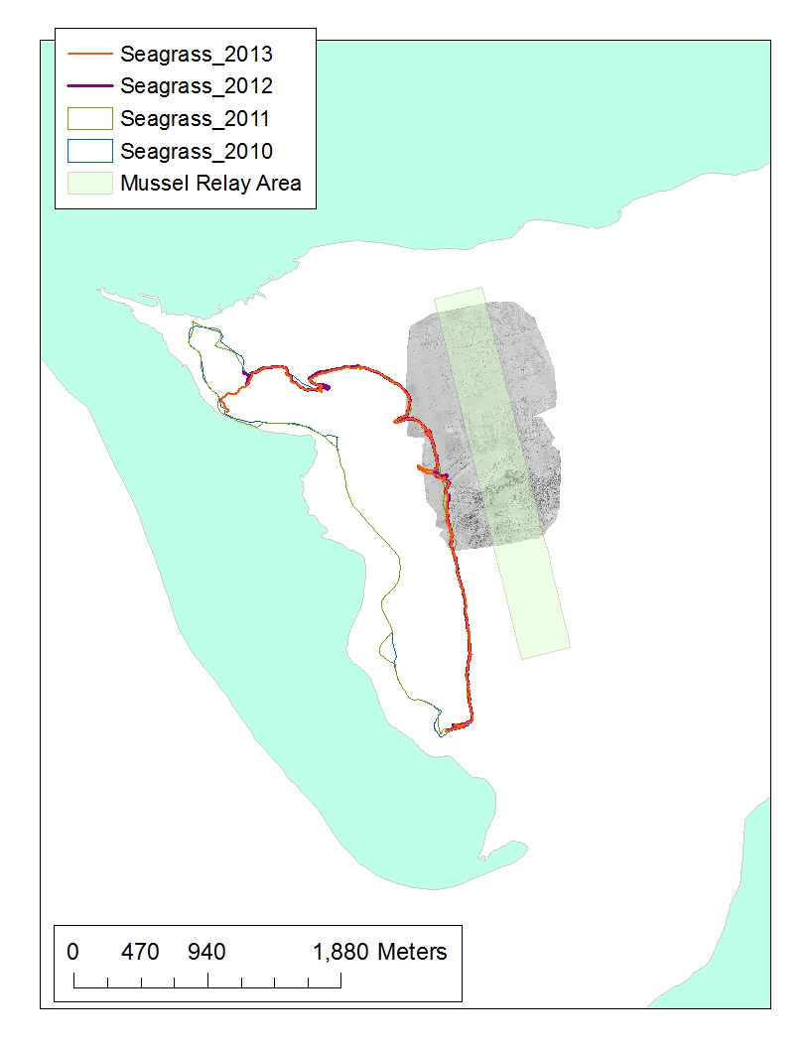

Fig. 1. UAV images (grey) obtained in Feb 2013 showing mussel cover in the intertidal area east of the seagrass bed and the eastern boundary of the seagrass bed as of August 8th 2013 in Castlemaine Harbour.

Image quality from the flyovers is high and capable of identifying and resolving mussel patches less than 0.5m in diameter. Mussel is clearly identifiable from sediment in the images. Mussel mud, seeping from the edges of the mussel patches is also identifiable and has a different signature to the mussel and surrounding sand (Fig. 2 and 3).

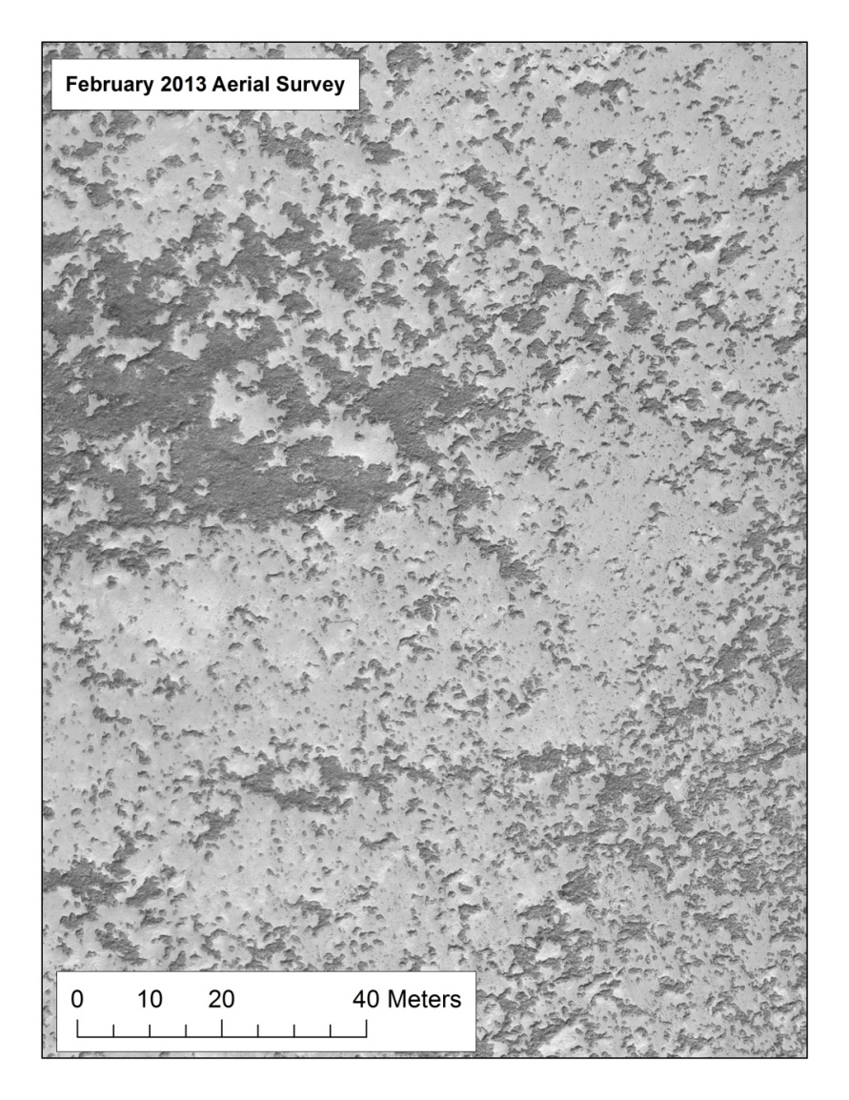

Fig. 2. Zoomed+ image of intertidal mussel patches on sand at Castlemaine Harbour on 25th February 2013. Mussels are dark patches. Sand is lightest grey and mussel mud is a darker grey. Note scale bar of 40m. Patches of mussel less than 0.5m in diameter are visible

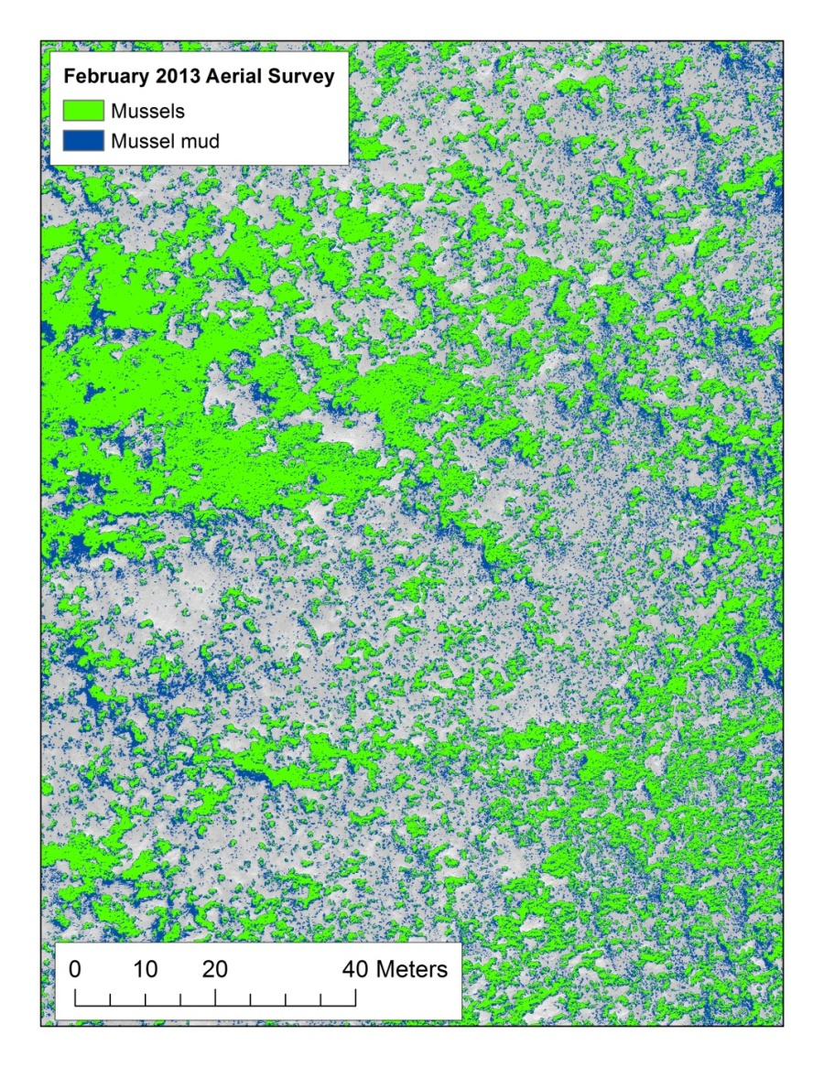

Fig. 3. Image analysis of intertidal mussel patches on sand at Castlemaine Harbour on February 25th, 2013. Mussels patches are green. Sand is grey. Mussel mud is blue. Note scale bar of 40m. Patches of mussel less than 0.5m in diameter are visible

**5.3.2 Seagrass**

The position of the eastern boundary of the seagrass bed (Fig. 1) is the same in 2013 as it was in 2012 and previous years. The is very little if any mussel within the bed in the north area or the southern area. Some patches of mussel occur close to the edge of the seagrass bed in the mid section. This is visible in Fig 1.

# 6.0 Conclusions and recommendations

* Permitting, regulatory monitoring and enforcement measures were successful and complied with the terms and conditions of the Fisheries Natura Plan and the Appropriate Assessment
* The position and extent of the seagrass bed is stable
* Mussel cover in the intertidal area is on average 8% and below the level with would trigger any management action or any new research on impacts on birds
* Seed mussel can be relayed in the intertidal area in autumn 2013

# Appendix 1

# Seed surveys

**Seed Mussel Survey Report for Cromane / Castlemaine Harbour – 8/05/12 to 11/05/12**

**Vessel**: MV T’Burke (BIM), Skipper John Murphy, Survey Officer Nicolas Chopin

**Equipment:** 1 meter dredge, 400 kHz side scan sonar, 0.1 m2 Day Grab

**Area Surveyed:** The channel between Inch Point and Rossbehy Point up to western Cromane Point (see Map 1).

**Survey Summary:**

Due to the late seed settlement last year, we expected to find mussels in the Rossbehy area, unfortunately no overwintered mussels were found. In 2011, it had been observed that the sand banks on each side of the channel had shifted since the previous year; this occurred again in 2012. The western sand bank known as The Bar, has moved eastward covering a major part of the 2009 and 2010 seed locations. The middle of the channel remains the same with a lot of rough ground with stones.

Very recent spatfall has been spotted on the stones over 25 hectares. The spat is 1 millimetre and under. Following previous estimation from 2009, 2010 and 2011, it can be estimated that this present settlement could produce up to 1,500 tonnes when the seed reaches 10 to 15 mm.

No signs were found further East/North in the channel; the side scan sonar data showed very hard ground with boulders, making dredging too hazardous.

*Bed coordinates (WGS 84 degrees, decimal minutes):*

|  |  |
| --- | --- |
| **Latitude** | **Longitude** |
| 52° 5.595' N | 9° 58.737' W |
| 52° 5.610' N | 9° 58.142' W |
| 52° 5.575' N | 9° 57.083' W |
| 52° 5.478' N | 9° 57.156' W |
| 52° 5.511' N | 9° 58.202' W |
| 52° 5.563' N | 9° 58.744' W |

NOTE: The area displayed on the attached Map 2 has been defined by using the side scan sonar data verified with the dredge and grab. These coordinates represents a simplified polygon of the possible settlement area.

A few small starfish were found in the dredges (2 to 3 cm diameters and 5 individuals maximum per dredge).

Due to the size of the spat observed in the area and the time of the year (the area is usually surveyed at the start of July), it is possible to expect a larger seed area and other settlements later in the season.

**Bottom type:**

Hard ground with stones and patches of coarse sand with shells.

**Recommendations:**

This settlement should be locally monitored for growth and predators, especially if there is low amount of rain (starfish are known to migrate on seed beds following the rise of salinity in the channel). This would be the key factor in deciding when to initiate the start of the fishery.

Nicolas Chopin

BIM Inshore Survey Officer

Aquaculture Technical Section

seed muscle survey areas castlemain harbour

seed mussels survey areas castlemain harbour

**Seed Mussel Survey Report for Growth and Predators Monitoring on the Cromane Settlement – 26-07-12**

**Vessel**: MV Western Adventure II, Skipper Arther McCarthy, Survey Officer Nicolas Chopin

**Equipment:** Standard dredge, 0.1 m2 Day Grab, underwater Spyball camera

**Area Surveyed:** The estimated spatfall area designated in early May 2012, in the channel between Rossbehy Point and Inch Point.

**Survey Summary:**

Following an early survey this year, spatfall was observed over a 25 hectares area in the channel between Inch Point and Rossbehy Point. At the time, a lot of very recent spat was covering the stones and the seaweed. In agreement with the recommendations made in the report at the time, a second survey was carried out on July 26th, to confirm that the spat has grown.

*Bed coordinates (WGS 84 degrees, decimal minutes):*

|  |  |
| --- | --- |
| **Latitude** | **Longitude** |
| 52° 5.595' N | 9° 58.737' W |
| 52° 5.610' N | 9° 58.142' W |
| 52° 5.575' N | 9° 57.083' W |
| 52° 5.478' N | 9° 57.156' W |
| 52° 5.511' N | 9° 58.202' W |
| 52° 5.563' N | 9° 58.744' W |

NOTE: The area displayed on the attached Map 2 has been established using the side scan sonar data verified with the dredge and grab. These coordinates represents a simplified polygon of the possible settlement.

The first tow with the dredge confirmed that the spat has grown well over the intervening three months. The average size of mussels found throughout the samples was between 8.5 to 9mm. Most of the seed population on the bed comprises of mussels in the 5 to 10 mm class, which represents over 50% of the samples content. The percentage of waste per sample varied from 7 to 48% (mainly small stones and a lot of byssus). A lot of small seed (under 5mm) was found within the byssus.

The average density on the main part of the bed varies from 7 to 9 kg of seed per meter square (from grab samples with error factor) and forms an even carpet on the seabed. The current seed mussel bed area is 21 hectares (in green on Map 2); the 4 hectares left are of a lesser density with a lot of stones. The current tonnage can be estimated at around 1,700 tonnes of seed (at the current size) for that area. Based on previous growth rates in the area this tonnage will increase before the fishing starts. Only a few starfish were observed on the underwater footage.

Another patch of seed mussels was found further East from the main bed (see Map 1). The average size of the seed is a bit bigger (10.5 mm). The underwater footage shows that the seed covers the seabed evenly and by comparing the samples and the video footage from the main bed, the density can be estimated at the same amount as the main bed (7 to 9 kg/m2).

The average depth of this bed is approximately 3 to 4 meters in a sub tidal area. No acoustic data was collected at this location so it is difficult to accurately estimate the extent of this settlement as well as its possible tonnage but from the grabs, dredge and camera survey the area was approximately 10 hectares giving a potential tonnage of 800 tons.

No starfish was observed on the underwater footage.

The coordinates for the centre of the area on the map are (in WGS 84 degrees, decimal minutes):

|  |  |
| --- | --- |
| **Latitude** | **Longitude** |
| 52° 5.583' N | 9° 56.029' W |

**Bottom type**: Small stones, shells and coarse sand.

**Recommendations:**

The seed mussel on the defined beds will be ready to fish on the opening date of September 6th 2012. Applying growth rates observed in previous years, to the growth period between the time of this survey and the opening of the fishery, we would conservatively expect the biomass of the seed mussels to increase to at least 3,000 tonnes (with 50% expected growth) by the opening on the 6th of September.

Nicolas Chopin

Inshore Survey Officer

BIM Aquaculture Technical Section

**Notes for the legend in Map 1 and 2:**

TD: Tows Dingle (with the 1 meter dredge)

GD: Grab Dingle (with the Day Grab)

